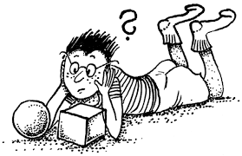 KLUB ZL – 19. 3. 2021- úkoly pro chytré hlavy

***SUDOKU***

|  |  |  |  |  |  |  |  |  |
| --- | --- | --- | --- | --- | --- | --- | --- | --- |
|  |  | **8** | **7** |  |  | **5** |  | **3** |
| **6** | **9** | **7** |  |  |  | **4** | **8** |  |
| **5** |  |  |  | **8** | **1** |  |  |  |
| **3** | **2** |  | **1** |  | **5** |  |  |  |
|  | **1** |  | **9** |  | **8** |  | **3** |  |
|  |  |  | **2** |  | **6** |  | **4** | **9** |
|  |  |  | **6** | **2** |  |  |  | **7** |
|  | **8** | **4** |  |  |  | **6** | **9** | **2** |
| **2** |  | **1** |  |  | **7** | **3** |  |  |