- Write the 3rd person singular of the verbs:

1. I join - he joins 2. I like - he ………… 3. I kiss - he …………….
4. I fly - he ……………. 5. I watch - he ………… 6. I enjoy - he …………….
7. I talk - he ……………. 8. I go - he ………… 9. I teach - he ……………
10. I buy - she …………… 11. I finish - she ……….. 12. I cry - she ……………

- Use the verbs in brackets to complete the sentences, as in the example:


1. I ..live.. (live) in Edinburgh. 2. He ………. (do) his homework every evening.
3. She’s a teacher. She ……….. (work) at primary school.
4. “Are you a singer?” “No, I’m a pilot. I ………….. (fly) aeroplanes.
5. Joan …………. (wash) her hair every day.
6. The museum …………….. (close) at seven in the evening.
7. Daniel ……………. (brush) his teeth every morning.
8. She ……………... (study) Science at university.
9. Every Saturday, Paul …………… (give) his dog a bath.
10. In the mornings, Betty …………… (take) her sister to school.
11. We ……… (go) to the swimming pool at the weekend.
12. John and Mary ………… (have) a cup of tea in the afternoon.

- Use the prompts to write sentences, as in the example:

- he / every day / work / on the computer → He works on the computer every day.
- Susana / at the weekend / do her laundry → ………………………………………………………….
- My friends and I / at the weekend / go fishing → …………………………………………………….
- he / every morning / read the newspaper → …………………………………………………………..
- Sharon / exercise / in the morning → …………………………………………………………………
- dinner / they / at 7:30 / eat → …………………………………………………………………………
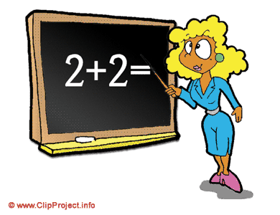
- Write questions and negations as in the example.

  - Tom lives in England. → Does Tom live in England? Tom doesn’t live in England.
  - Mr Simpson teaches Chemistry. →…………………………………………………………………..
  - You like playing computer games. → ……………………………………………………………….
  - John and Sue work in a café. → ……………………………………………………………………..
  - We do the shopping on Saturdays. → ……………………………………………………………….
  - The baby cries all the time. → ……………………………………………………………………….

V. Fill in do / don’t, does / doesn’t.

1. Sam speaks French, but he ……. Speak Russian. 2. Ann …… like jazz music but she likes pop music.
3. “…….. she play the saxophone?” “No, she ……”. 4. Where ….. you work?
5. He …….. go to school on Sunday. 6. What …... you have for dinner?


VI. Match the questions to the answers.

1. What time does she get up? A. She goes to bed at 10:00.
2. How does she go to school? B. She walks to school.
3. Does she have breakfast every day? C. She gets up at 7:00.
4. What does she do in the afternoon? D. No, she doesn’t.
5. When does she go to bed? E. She does her homework.
☺ Good luck ☺

