Aj 7. B, 2nd November Project 2/ U1

***Grammar revision***

***1. Present Simple affirmative***

(kontrola cvičení)

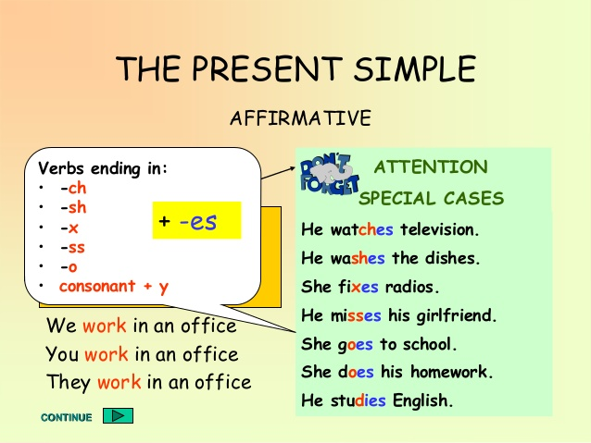She_____takes__________(**take**) a bath every day.

He ____swims___________­(**swim**) in the afternoon.

They___watch___________(**watch**) TV every day.

We_____cook__________(**cook**) twice a week.

You______play_________(**play**)computer games once a day.

I_____like____________(**like**)sweets.

The cats___run_________(**run**)in the evening.

The boys____love________(**love**)games.

Ann ______studies__________(**study**)English regularly.

Peter ____cries___________(**cry**) when he watches a sad movie.

A parrot__has___________(**have**)a lot of feathers.

***2. Present simple negative***

- grammar video https://www.youtube.com/watch?v=Jz7BPcnqlXc

- kontrola cv. v PS str. 5/5, 6

***3. Kontrola***

1. PS 5/5

Harry doesn´t walk to school. He takes the bus to school.

Harry doesn´t like Maths. He likes Geography.

After school Harry doesn´t play tennis. He goes swimming.

Harry´s friends don´t play computer games. They watch TV.

Harry´s parents don´t get home at half past five. They get home at quarter past five.

2. PS str. 66

1. a, b, b, b, d

2. twelve, on, live, seventh, get up, at, at, third, starts, finishes

3. tvé vlastní odpovědi