Anglický jazyk 9. A

Dobrý den, připomínám úkoly z Aj na příští týden. Vypracujte prosím zadané úkoly v pracovních listech . Kdyby náhodou někdo pracovní list ztratil nebo neměl, úkoly, které jsou níže, napište do školního sešitu.

Past Simple (regular verbs)

##  Write the Past Simple form of the verbs below in the correct column.

* repeat  worry  finish  start  phone  call  miss  enjoy  visit  marry  listen  cry 
  + play  hate  wash  climb  live  arrive  talk  look  stay  ask  clean 
    - travel  open  like  walk  carry  stop  mix  plan  decide  tidy 

|  |  |  |  |
| --- | --- | --- | --- |
| **- d** | **- ed** | **cons + y**  **- ied** | **double cons**  **+ - ed** |
|  |  |  |  |

##  Write sentences in Past Simple:

1. **Affirmative (utvořte věty v minulém čase)**
2. **My sister / tidy / her room / yesterday morning. 1-**
3. **We / live / in New York / in 1997. 1-**
4. **Tom / travel / to Dublin / last night. 1-**
5. **I / clean / my teeth / twice / yesterday. 1-**
6. **John / stay / at Mary’s house / last summer. 1-**
7. **You / start / school / ten years ago. 1-**
8. **The film / end / very late / last weekend. 1-**
9. **Sue and Pat / talk / on the phone / yesterday. 1-**

 **Write the verbs in brackets in** Past Simple**.**

* My sister (tidy) her

bedroom yesterday morning.

* We (phone) our

cousins last week.

* The girls (play) on the

computer last night.

* I (travel) to Paris

three months ago.

* + John (stay) at his

granny’s house last summer.

* + The film (end) very late

yesterday.

* + My family (live) in New York

in 1995.

* + You (clean) your teeth

three times yesterday.

 **Complete the sentences with the verbs below in** Past Simple**.**



1. Lucy her birthday presents.
2. 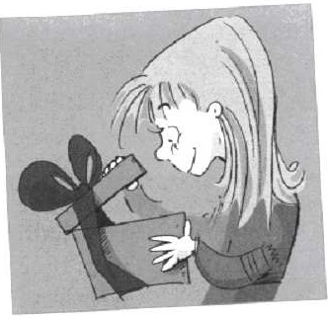Last weekend I in the mountains for 2 hours.
3. We the party very much.
4. Ken to his favourite CD yesterday.
5. My sister Maths for an exam.
6. They to the USA in 2003.
7. Dad his car last weekend.
8. The film at 11:30.

##  What did you do yesterday? Put a ( ) or a ( ).

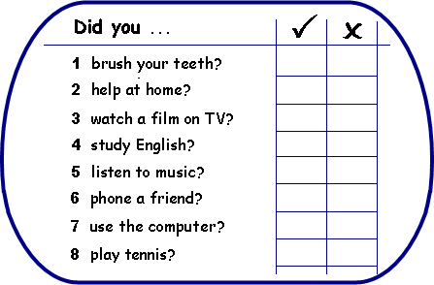

 **Write questions about the previous activities and answer them.**

**1-** Did you ............................................................. yesterday? ......................................................

**2-** ................................................................................................? ......................................................

**3-** ................................................................................................? .......................................................

**4-** ................................................................................................? .......................................................

**5-** ................................................................................................? .......................................................

**6-** ................................................................................................? .......................................................

**7-** ................................................................................................? .......................................................

**8-** ................................................................................................? .......................................................

Past Simple (irregular verbs)

##  Complete the table.

**Then complete the sentences with the Past Simple of the verbs in brackets.**

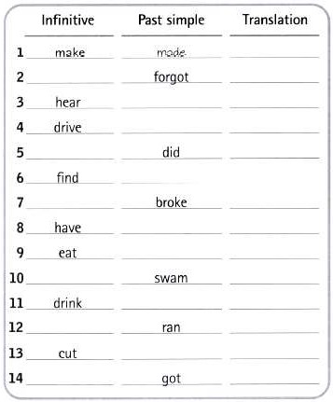

* + - She (go) to school on foot yesterday.
    - Paul (eat) 2 sandwiches and an apple.
    - I (get) up very early last night.
    - They (find) 50 euros in the street.
* My dad (give) me a CD for my birthday.
* Ana (have) a bath last Sunday.
* We (swim) in the Mediterranean sea.
* Joe (write) a letter to Mary 2 days ago.

 **Complete the sentences. Use the *negative form* of the underlined verbs.**

**Yesterday ...**

* + I drank coffee but I tea.
  + She found her purse but she her keys.
  + The children broke the window but they the door.
  + He had a shower but he breakfast.
  + My father made a cake but he any pastries.
  + We spoke English and French but we German.

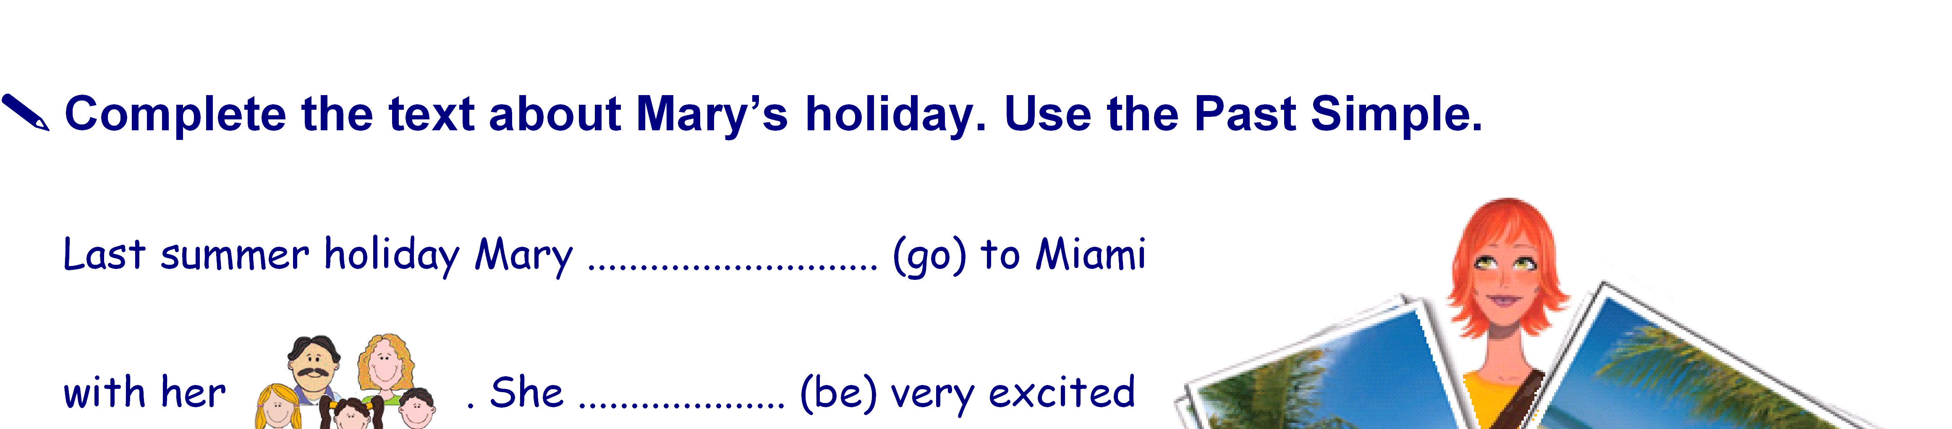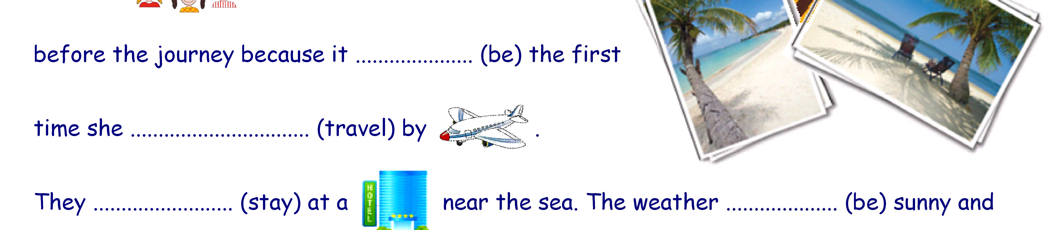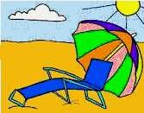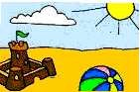

Mary likes

and the children love

.

So Mary and Mum ................................ (sunbathe) and the children (play) with

the ball and .......................... (make) sandcastles. Dad (swim) in the sea and

........................ (read) the  under the umbrella. We usually (have) lunch in

a 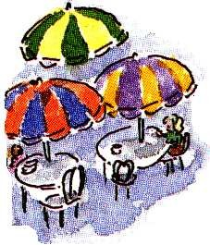 near the beach. In the afternoon they (visit) very interesting

places. One day They ......................... (go) out in a  . It (be) amazing!

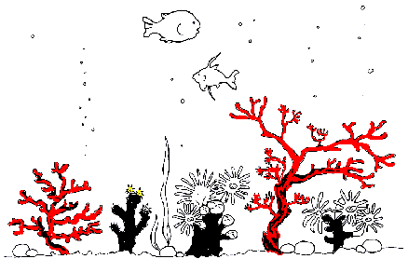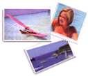They .......................... (like) the best. They ...................... (see) different 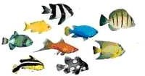, some 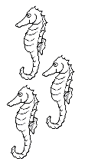and even a 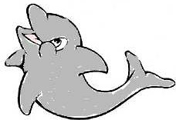.............................. (jump) in front of the boat. They also

......................... (watch) some people feed the fish. Mary ...................... (take) a lot of . The family (enjoy) a lot.

The last day it ........................ (rain). The whole family (go) to a shopping centre.

They ............................... (buy) some souvenirs. In the afternoon they (return)

home. Mary and her family (have) a great time there !!!!

# WRITE sentences in PAST SIMPLE:

1. **Negative (věty v levém sloupci převeďte do záporu)**
2. **Interrogative (Yes / No) (věty v pravém sloupci převeďte na otázky)**
3. **He / phone / a friend / an hour ago. 1-**

**2-**

**3-**

1. **My father / buy / a jeep / last week. 1-**

**2-**

**3-**

1. **The girls / wear / skirts / to the party 1-**

**2-**

**3-**

**) I / wash / my hair / last night 1-**

**2-**

**3-**

1. **Jane / send / four e-mails / to Lisa 1-**

**2-**

**3-**

1. **The old lady / carry / heavy bags / yesterday morning**

**1-**

**2-**

**3-**

1. **The film / end / very late / last weekend 1-**

**2-**

**3-**

1. **They / go / to bed / at midnight 1-**

**2-**

**3-**

1. **The children / play / tennis and basketball / at the sports centre.**

**1-**

**2-**

**3-**

1. **You / do / your homework / last weekend. 1-**

**2-**

**3-**

1. **My friend / study / German / last year. 1-**

**2-**

**3-**

1. **I / get up / at seven / last Sunday morning 1-**

**2-**

**3-**

1. **We / visit / our friends / yesterday evening 1-**

**2-**

**3-**

1. **She / have lunch / in an Italian restaurant 1-**

**2-**

**3-**

1. **They / watch / TV / in the living room 1-**

**2-**

**3-**

1. **He / drink / orange juice / for breakfast 1-**

**2-**

**3-**