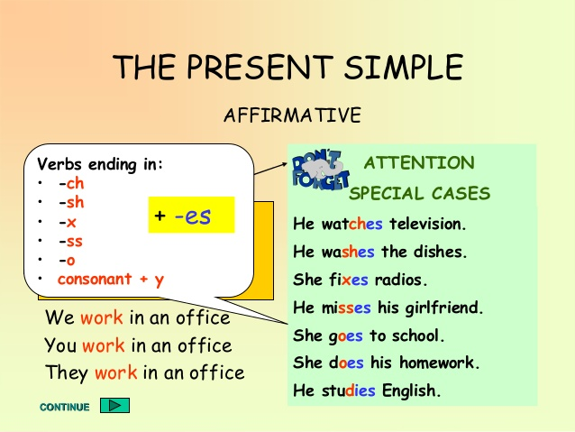Aj 7. B, 23. 10.

Opakování

1. PS str. 12/1 Zopakujte si měsíce v roce, zapište je do tabulky.

2. Zopakujte si pravidla pro tvoření 3. osoby č. j.

3. Následující cvičení napište do školního sešitu

1. She_______________(**take**) a bath every day.
2. He _______________­(**swim**) in the afternoon.
3. They______________(**watch**) TV every day.
4. We_______________(**cook**) twice a week.
5. You_______________(**play**)computer games once a day.
6. I_________________(**like**)sweets.
7. The cats____________(**run**)in the evening.
8. The boys____________(**love**)games.
9. Ann ________________(**study**)English regularly.
10. Peter _______________(**cry**) when he watches a sad movie.
11. A parrot_____________(**have**)a lot of feathers.